Week 2 Report: Exploratory Data Analysis and Visualization

1. Objective
This report presents an exploratory data analysis of the Iris dataset using Python libraries Pandas, Matplotlib and Seaborn. The objective is to summarize the dataset, identify trends and visualize relationships between variables.

2. Dataset Description
The Iris dataset contains 150 flower observations with four numerical features and one categorical species column.
Feature | Description
Rows | 150
Columns | 5
Species | Setosa, Versicolor, Virginica
Missing Values | 0

3. Data Cleaning
Missing values and duplicate records were checked. The dataset contained no missing values and duplicate rows were removed if present.

4. Summary Statistics
sepal length (cm) sepal width (cm) petal length (cm) petal width (cm)
count 150.000000 150.000000 150.000000 150.000000
mean 5.843333 3.057333 3.758000 1.199333
std 0.828066 0.435866 1.765298 0.762238
min 4.300000 2.000000 1.000000 0.100000
25% 5.100000 2.800000 1.600000 0.300000
50% 5.800000 3.000000 4.350000 1.300000
75% 6.400000 3.300000 5.100000 1.800000
max 7.900000 4.400000 6.900000 2.500000

5. Visualization 1: Count Plot
The count plot shows that each species has an equal number of observations.
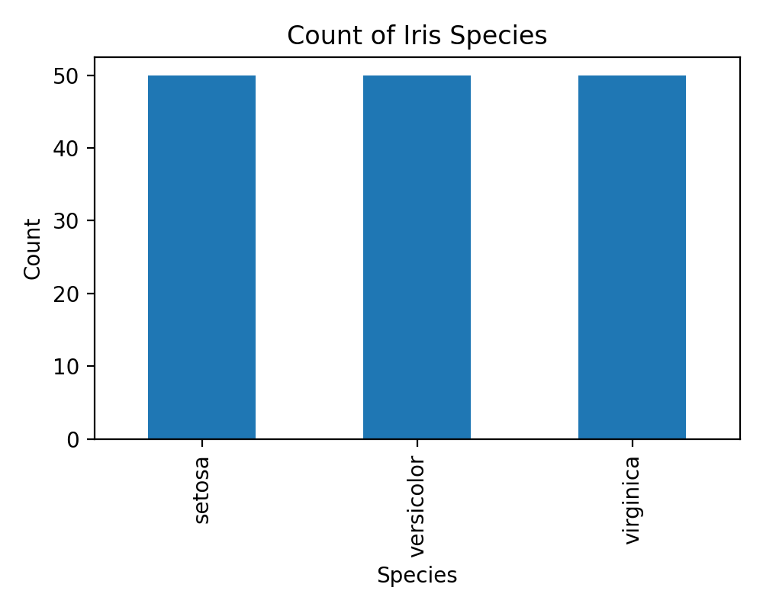

6. Visualization 2: Histogram
The histogram shows the distribution of petal length.
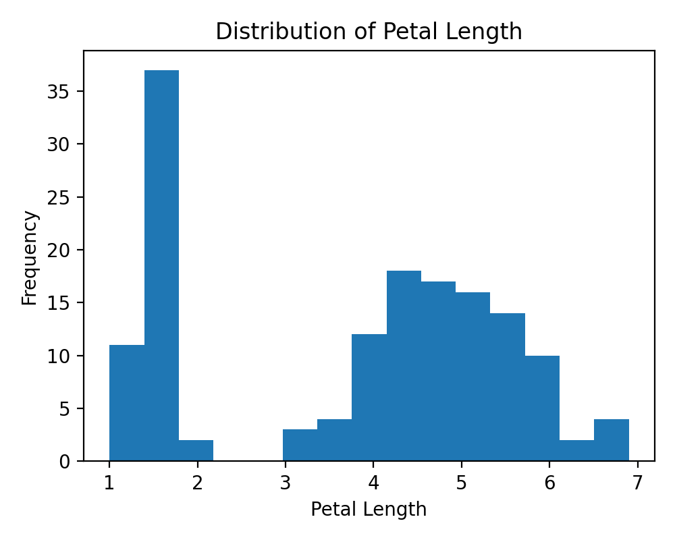

7. Visualization 3: Scatter Plot
The scatter plot shows a strong positive relationship between petal length and petal width.
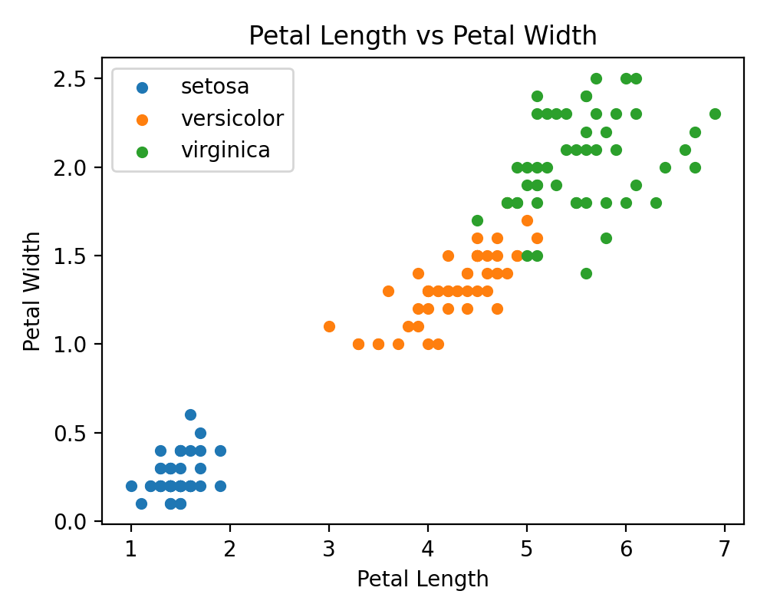

8. Visualization 4: Box Plot
The box plot compares sepal length across species.
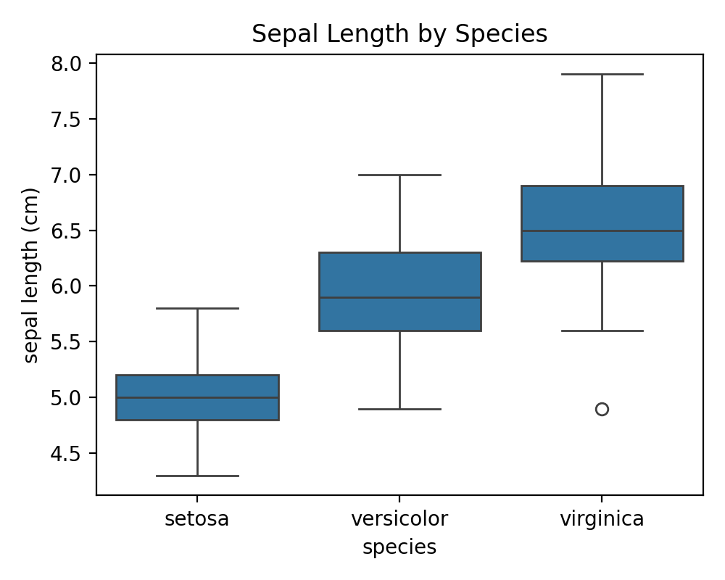

9. Visualization 5: Correlation Heatmap
The heatmap displays correlations among numerical variables.
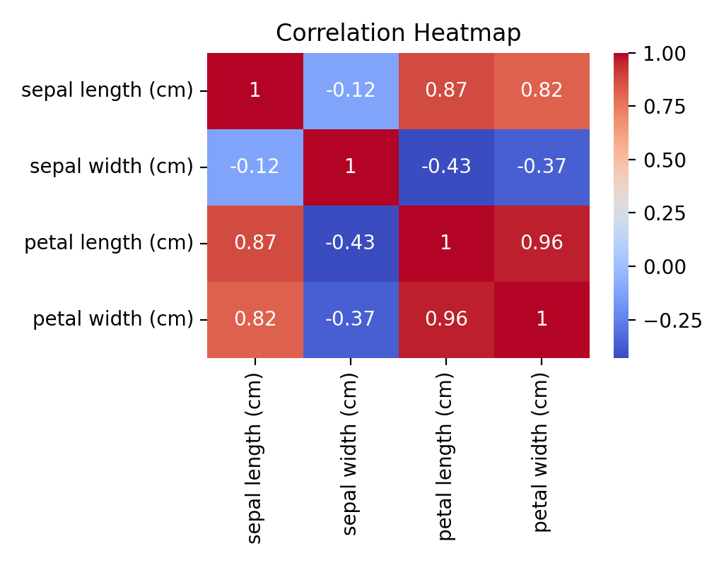

10. Key Findings
- Petal length and petal width have a strong positive correlation.
- Setosa is clearly separated from the other two species.
- Virginica has the largest average flower measurements.
- The dataset is clean and suitable for analysis.
- EDA helps discover trends and relationships before predictive modeling.

11. Conclusion
Exploratory Data Analysis is an important step before machine learning or business analytics. In this project, the Iris dataset was analyzed using Pandas, Matplotlib, and Seaborn. Statistical summaries, count plots, histograms, scatter plots, box plots, and correlation heatmaps were created to understand relationships among features. The analysis showed that petal measurements are highly correlated and species can be distinguished visually. This project demonstrates practical skills in data cleaning, visualization, and interpretation.

